7. Subsistence fishing
A total of 27 subsistence fishing trips were conducted between January and October this year. Pelagic fish species have been targeted with preference in an attempt to shift the emphasis from reef fish species. Pelagic fish such as Jacks and Tunas are ‘safer’ to utilize as a food resource as these fish do not depend on the reef for their survival and are therefore not as limited in numbers. Long lived, territorial reef fish species such as the Groupers are the least ‘safe’ and are easily over-exploited. The total number and weight of pelagic fish species is an underestimate as there was some confusion at the beginning of the year as to which species were to be entered into the database.

Catch per unit effort for the period of January to October 2003 was calculated at 52.6 kg per trip or 27 kg per hour. This data has not been presented with that of preceding years as no significant conclusions can be drawn from such comparisons as yet (dataset too small).

Most fishing trips were conducted around West Grande Terre, Anse Var and the main channel areas.

Table 38 represents the total number and weight of the various families. This table is further broken down into the species category in appendix 8.

Table 38: Numbers and total weight (kg) per family of fish caught for consumption between January and October 2003
Family | Number of fish | Total weight
Groupers (Serranidae) | 320 | 581
Tunas (Scombridae) | 18 | 206.5
Snappers (Lutjanidae) | 192 | 146.6
Jacks (Carangidae) | 42 | 295
Emperors (Lethrinidae) | 72 | 157.5
Barracudas (Shyraenidae) | 10 | 35.5
Totals | 654 | 1422.1

The five species contributing the largest percentages to the total weight are listed in table 39. This is the first time that the pelagic species Caranx Ignobilis and Acanthocybium solandri have outweighed the more palatable species (to the Seychellois palate!) such as Lethrinus nebulosus and Epinephelus multinotatus. This does not mean that there is a shortage of the palatable species; it simply means that the freezer has been kept full of pelagic species.

Table 39: The top 5 ranking species of fish in weight caught between January and October 2003
Scientific name | # | Weight | % of total catch
Variola louti | 116 | 217 | 15.3
Caranx ignobilis | 15 | 190 | 13.4
Epinephelus socialis | 56 | 148 | 10.4
Acanthocybium solandri | 9 | 117 | 8.2
Lethrinus nebulosus | 46 | 116 | 8.2

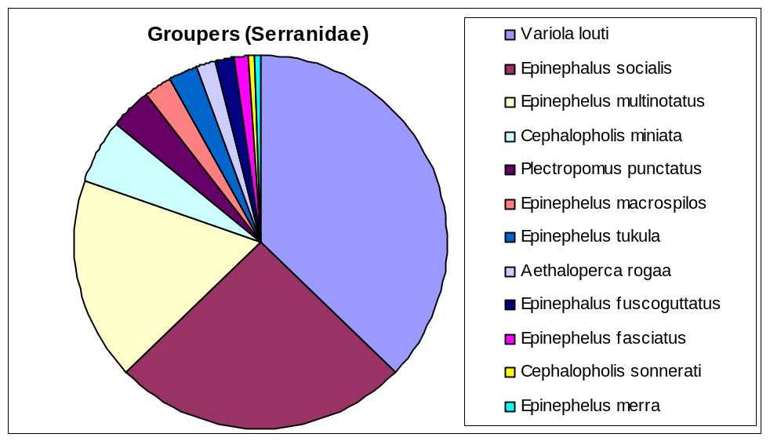
Figure 74: The proportion of various contributing species to the total catch of the Serranidae family

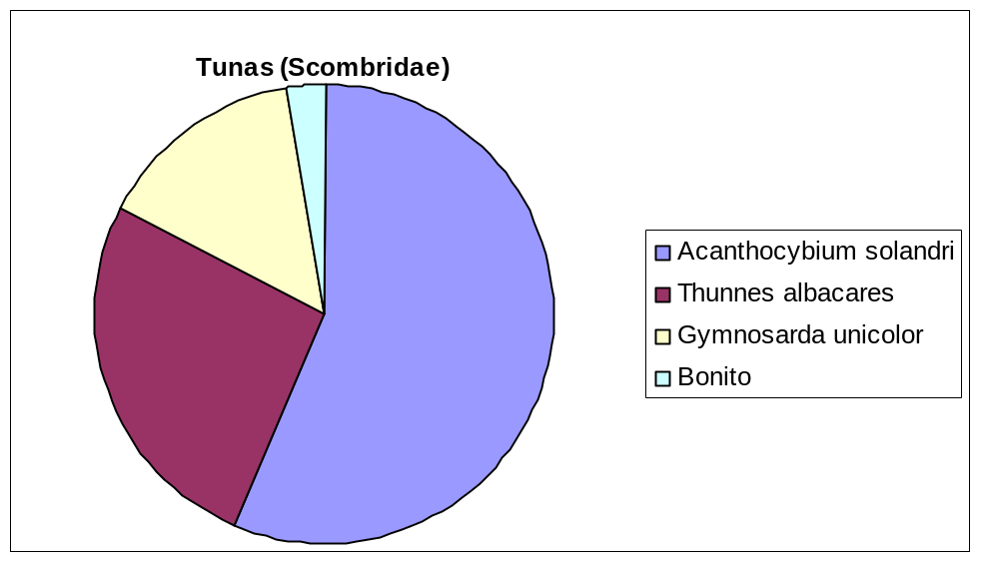
Figure 75: The proportion of various contributing species to the total catch of the Scombridae family

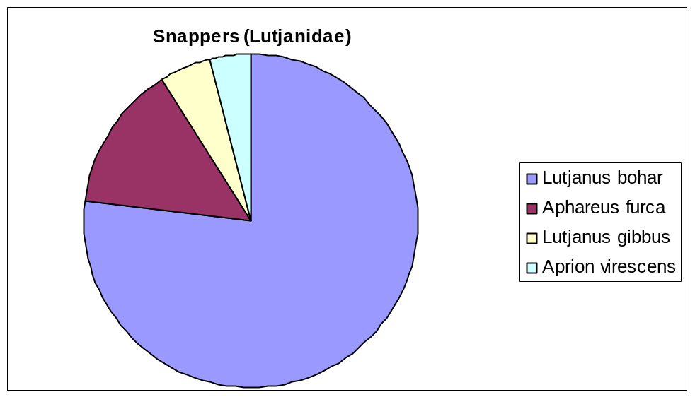
Figure 76: The proportion of various contributing species to the total catch of the Lutjanidae family
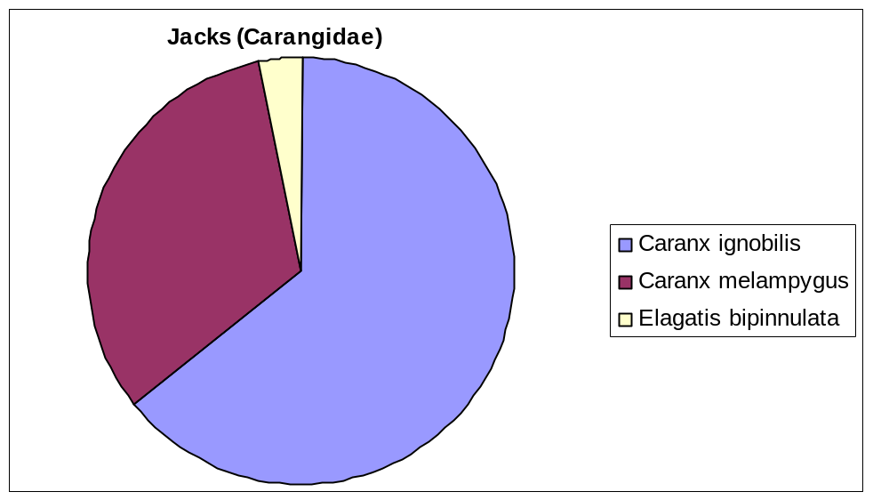
Figure 77: The proportion of various contributing species to the total catch of the Carangidae family

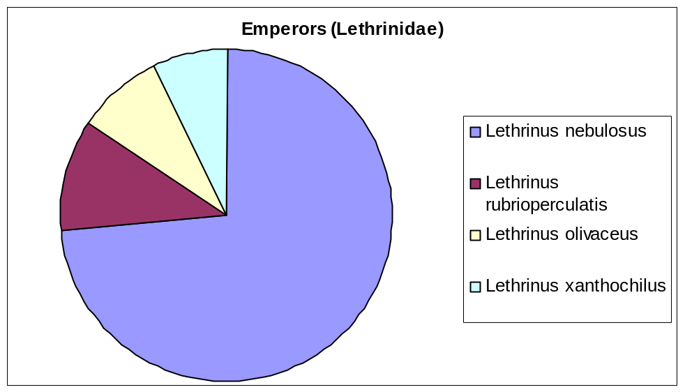
Figure 78: The proportion of various contributing species to the total catch of the Lethrinidae family

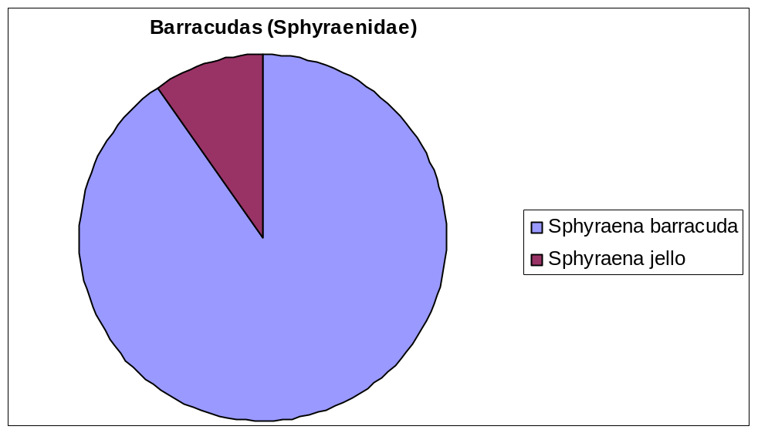
Figure 79: The proportion of various contributing species to the total catch of the Sphyraenidae family

